Order Of Service

Singing: Psalm 145—CW page 119

Reading: Psalm 102:1-17

Opening Hymn: TLH 330

Reading: Acts 20:1-6

Request Hymn: CW Supplement 702

Reading: Matthew 7:24-29

Sermon Hymn: TLH 326

Sermon Text: Mark 7:14-23

The Human Heart

Prayer

The Apostles’ Creed, TLH page 12

Holy Communion

The Lord's Prayer

The Blessing

Closing Hymn: TLH 322

* * * * * * * * * * *

Bible Study: Lambs: Turtle
Sheep: Proverbs 18:11-15



Ore Boat At Sunset In Duluth

Water
Of
Life

16 June 2019

W A T E R O F L I F E

Independent Christian Church—Conservative Lutheran Doctrine

Worship Service: 9:30 a.m. Bible Study: 10:45 a.m.

Larry Cooper, Pastor E-Mail address:
111 N. Ridge Road lcooper@wateroflife.cc
Coon Valley, WI 54623 Web Site:
www.wateroflife.cc

* * * * * * * * * * * * * * * * * * * * * * * * * * *

Sermon Text: Mark 7:14-23

The Human Heart

* * * * * * * * * * * * * * * * * * * * * * * * * * *

Mark 7:14 And when he had called all the people unto him, he said unto them, Hearken unto me every one of you, and understand:
:15 There is nothing from without a man, that entering into him can defile him: but the things which come out of him, those are they that defile the man.
:16 If any man have ears to hear, let him hear.
:17 And when he was entered into the house from the people, his disciples asked him concerning the parable.
:18 And he saith unto them, Are ye so without understanding also? Do ye not perceive, that whatsoever thing from without entereth into the man, it cannot defile him;
:19 Because it entereth not into his heart, but into the belly, and goeth out into the draught, purging all meats?
:20 And he said, That which cometh out of the man, that defileth the man.
:21 For from within, out of the heart of men, proceed evil thoughts, adulteries, fornications, murders,
:22 Thefts, covetousness, wickedness, deceit, lasciviousness, an evil eye, blasphemy, pride, foolishness:
:23 All these evil things come from within, and defile the man.

* * * * * * * * * *

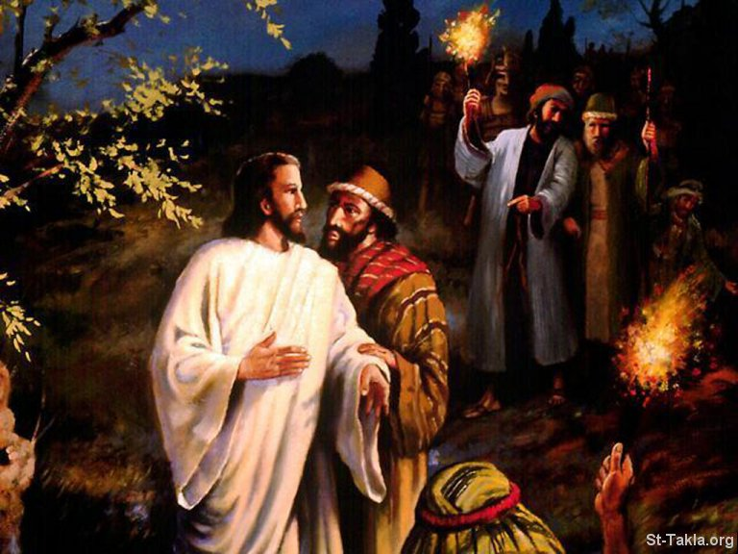

Mark 14:43 And immediately, while he yet spake, cometh Judas, one of the twelve, and with him a great multitude with swords and staves, from the chief priests and the scribes and the elders.
:44 And he that betrayed him had given them a token, saying, Whomsoever I shall kiss, that same is he; take him, and lead him away safely.
:45 And as soon as he was come, he goeth straightway to him, and saith, Master, master; and kissed him.

